**Lab | SQL Queries 2**

1. Select all the actors with the first name ‘Scarlett’.

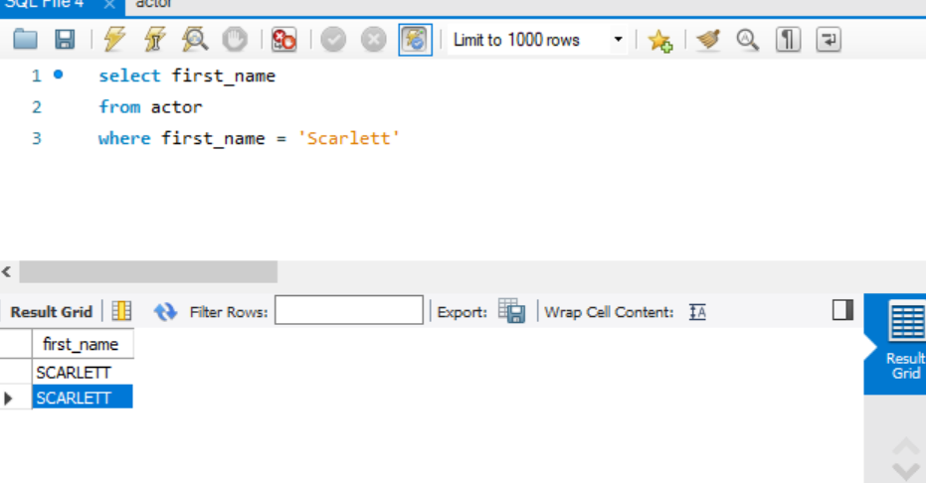

1. Select all the actors with the last name ‘Johansson’.

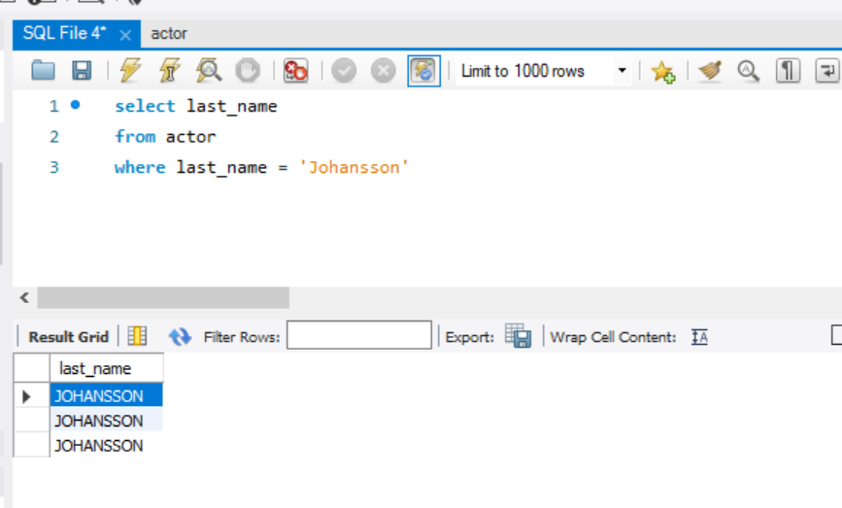

1. How many films (movies) are available for rent?

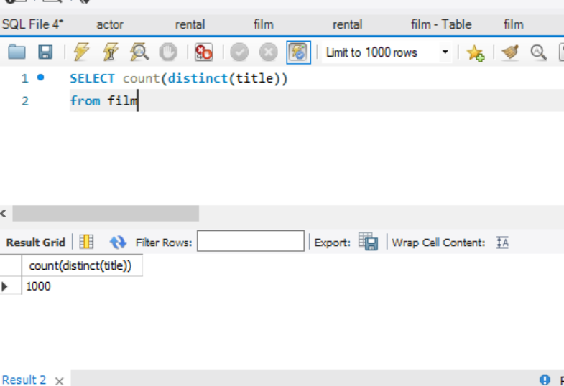

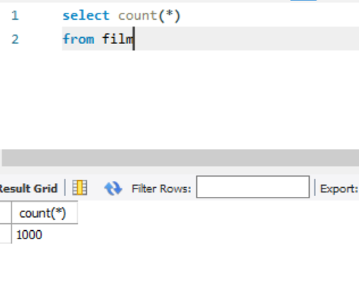

1. How many films have been rented?

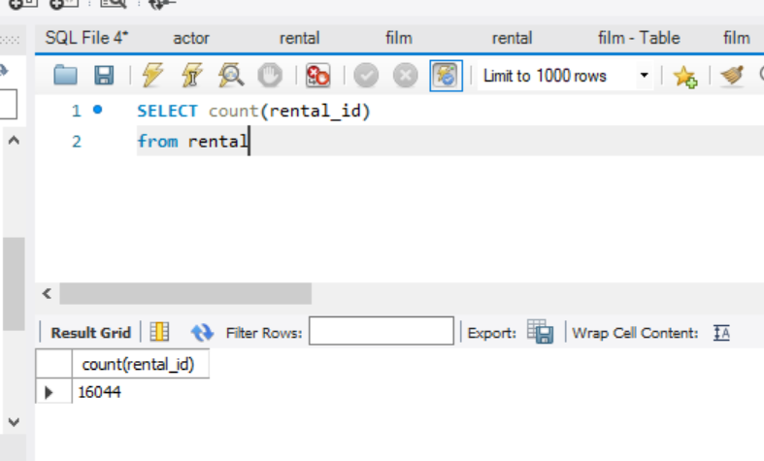

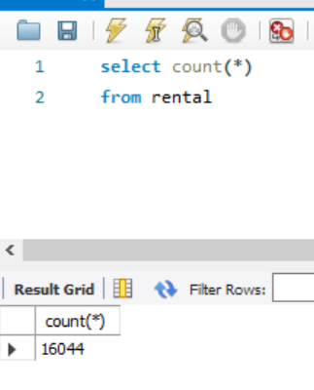

1. What is the shortest and longest rental period?

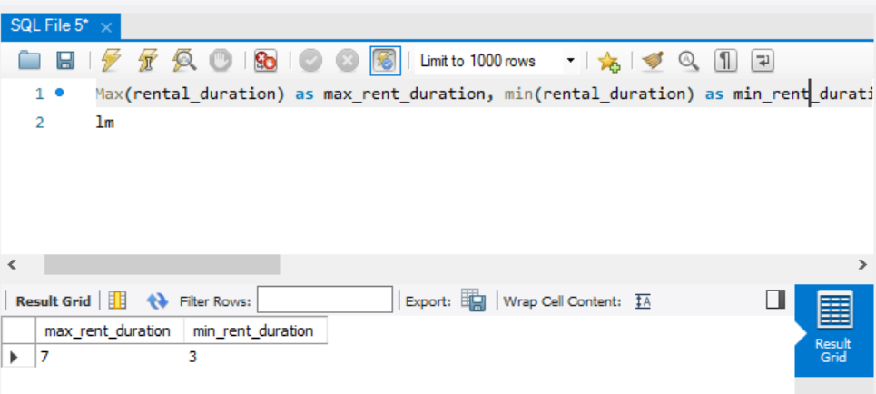

1. What are the shortest and longest movie duration? Name the values max_duration and min_duration.

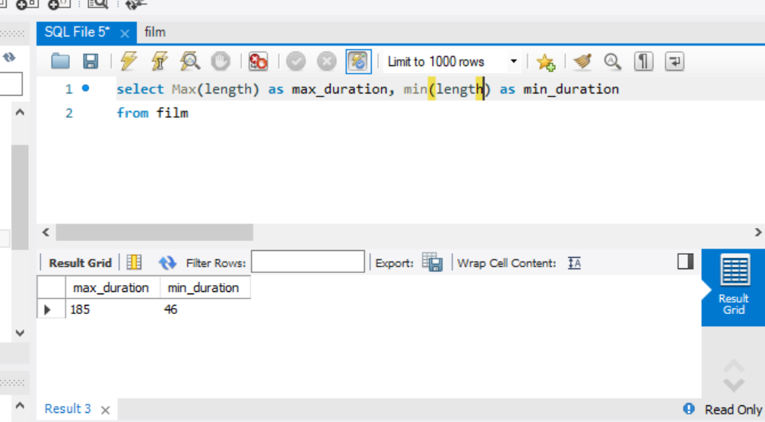

1. What's the average movie duration?

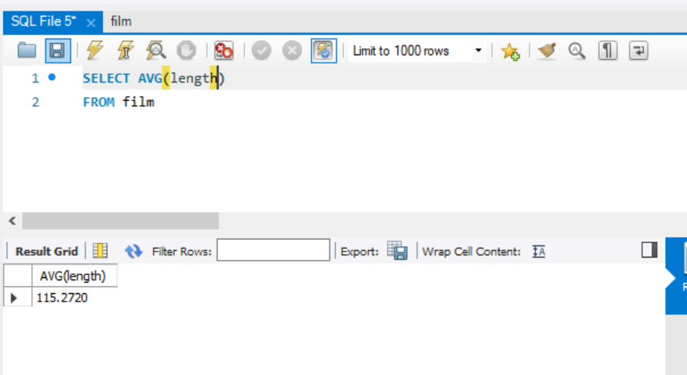

1. What's the average movie duration expressed in format (hours, minutes)?

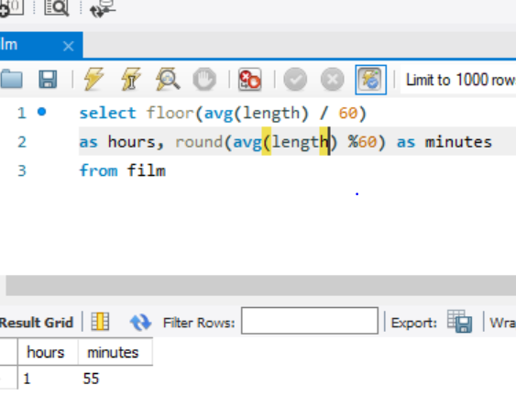

1. How many movies longer than 3 hours?

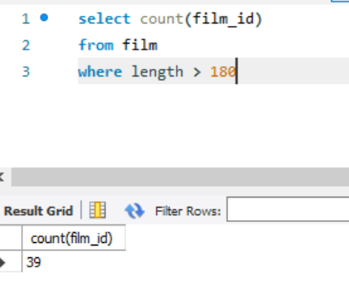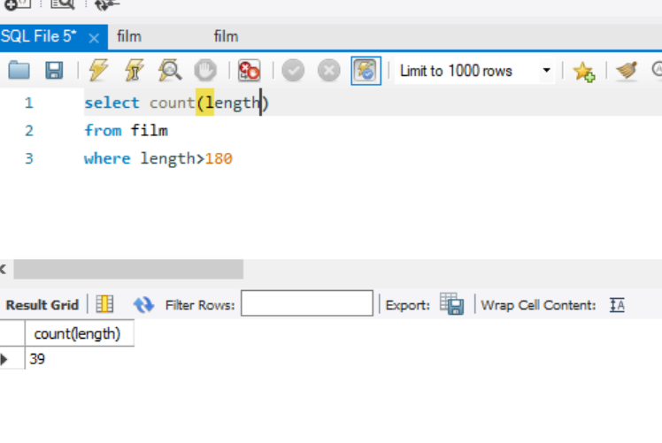

1. Get the name and email formatted in 2 columns. Example: Mary SMITH - [*mary.smith@sakilacustomer.org*](mailto:mary.smith@sakilacustomer.org).

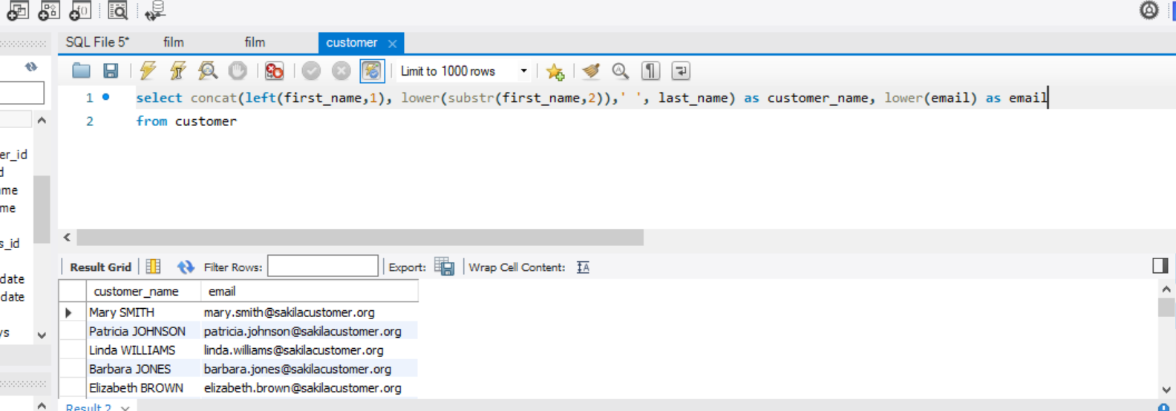

1. What's the length of the longest film title?

